


MKTG90011 Marketing Research

Understanding the Impact an Athleisure Brand - Lululemon Has On A Growing Loneliness Economy In Australia

Semester 1, 2026
Seminar: Wednesday 6 PM - 9 PM
Dr. Aysha Arafat

Group 10

Shania Mathias: 1636025
Mallika Moghe: 1645643
Pooja Bakari: 1775775
Lim Jing Yi: 1812414
Junlin Fu: 1358466

Word Count:

AI Declaration

Table of Contents

Executive Summary

1. Introduction

Rising social isolation has a considerable effect on the market. Recent Australian research has suggested that nearly 1/3 of Australia feels socially isolated, with a 58% rise specifically amongst Gen-Z (Real Relationships Report, 2025). Economic pressures such as the rising cost of living concur with this so-called ‘friendship recession’, resulting in nearly 44% Australians choosing to stay indoors (Real Relationships Report, 2025). Given this, most individuals are turning towards novel connections such as AI and social media, with users claiming a closer bond with ChatGPT than their real-life friends. Another novel attachment involves retail therapy, as many consumer studies have suggested, lonely consumers tend to cope by enriching brand attachments, especially amongst individualistic cultures (Ng, 2025). Above this, such attachment also funnels its way through compensatory consumption satisfying unmet needs of self-esteem and belonging (Huang & Li, 2023).

Lululemon, a premium activewear and wellness brand, places itself at the crux of such trends. In offering yoga classes, running clubs and mental health initiatives (‘Lululemon Gives’), it places itself as a community-centric brand fostering connection. However, its highly aspirational messaging (idealistic body structures and lifestyles) risks appearing ultra exclusive and surreal in nature (Sousa, 2016). Given this, our managerial decision problem focuses on - How Lululemon should adjust their brand narrative and marketing strategy to authentically tackle consumer loneliness and promote inclusion.

2. Literature Review

2.1 Loneliness and Consumer Behavior

Humans have an inherent need to belong and experience connection between one another, the gap between this desired feeling and the actual state is what we refer to as loneliness (Ng, 2025). As explained above, this painful feeling can often result in various coping mechanisms. Australian research estimated that loneliness can cost the country about $2.7 billion in health and productivity losses (Lu, 2021). Making loneliness a potential burden on public health and the economy.

Loneliness can alter consumption behaviour. Most socially secluded individuals seek material or symbolic forms of comfort. For instance, impulsive buying and materialistic needs are often seen as a trend amongst lonely consumers (Huang & Li 2023), inadvertently using their purchasing power as a form of escapism. This need comes from a fantasised alternate reality that shopping provides as compensation for the lack of social belonging by attaching material objects to one's sense of being (Mendini & Furcheim, 2025). These behaviours, while providing short-term satisfaction in terms of self-esteem and affiliation, are essentially disillusioned connections that cannot truly substitute real relationships.

Moreover, lonely consumers also look towards social substitution via parasocial relationships with brands, influencers, and even AI softwares (Huang & Li, 2023). In this case, brands tend to be anthropomorphised into ‘surrogate friends’ Huang & Li, (2023) in turn, increasing emotional attachment towards said brand. This circumstance is often witnessed within individualistic/western cultures such as Australia, where many people lean towards brand identities in the form of ‘brand love’ to fulfil their need for inclusivity (Ng, 2025). Similarly, online groups, cliques, and communal gatherings built around brands, can provide resonance and familiarity. Lonely consumers with a strong need to belong are more likely to join socially-acceptable brand communities (Snyder & Newman (2019), as a means to relieve feeling ‘left out’ and improve relatedness satisfaction. For example, being affiliated with an athletic community (run clubs) has been found to yield significant benefits, as this makes them feel respected and valued through consistent interaction with the referent group (Sung & Gounko, 2023). Therefore, a brand like Lululemon when initiating community programs and events, has the ability to measurably mitigate loneliness, and garner authentic connections.

2.2 Escapism, Self-Identity and Advertising

Almost every advertising piece offers consumers a form of emotional escape through storytelling and sensory experiences, allowing individuals to temporarily reprieve from daily stresses and monotony. In a capitalist society such as ours, these ideal lifestyles experienced by the ideal persona, can become aspirational fantasies that consumers can live on vicariously (Curtis et al., 2017). However, the extent to which brands can successfully leverage this depends on consumer traits. Lonely individuals seeking social affiliation may respond differently to aspirational imagery versus emotional messaging. On one hand, aspirational imagery could allow lonely individuals to fantasise/escape into a realm of their ideal self or community. On the other hand, the self discrepancy theory Higgins (1987) suggests that individuals undergo tension when a discrepancy exists between their real and ideal self. Lululemon’s marketing, with its polished identity, often appeals to an idealised version of who one could be if they committed to being fit. This could result in either of the two feelings: motivation or induced inadequacy. Conversely, empathetic appeals that recognise loneliness might be more resonant and reassuring, yet they risk appearing overtly needy. Given this, brands need to put considerable efforts into understanding which messaging tone their audience seeks in a loneliness economy.

2.3 Brand Authenticity and Inclusion

In a virtual world, consumers value brand authenticity more than before. They see them as being genuine, transparent and true to their mission (Beverland & Farrelly, 2010). For Lululemon, this was witnessed through free yoga classes, well-being initiatives etc. A 2024 report by the brand suggested that 74% of Australians are setting boundaries to maintain their health. However, the same report highlights that constant societal pressure to remain ‘healthy’ has left individuals feeling stressed and burnt out - signifying a dissonance in the lack of agency between a lifestyle chosen and forced upon. Lululemon’s recent campaign ‘Together We Grow’, links movement to social connection, stating that physical activity as a form of socialising can increase wellbeing by 23% (Lululemon Media, 2024). However, authenticity also means inclusivity. Making critics argue that highly aspirational imaging can suggest elitist/narrow thinking. For example, this can be witnessed through the intersection of Lululemon activewear, pilates culture and the ubiquitous Stanley tumbler that masks the desire for this aesthetic as personal wellness. At high price points and niche imaging, such social paradigms have resulted in some consumers feeling alienated (Muniz & O’Guinn, 2001). For this reason, the challenge for Lululemon is to retain its strong brand identity, yet simultaneously seeming as a genuinely warm and accessible brand for lonely/marginalised consumers. Carefully balancing between aspirational symbolism and emotional messaging is essential to avoid allegations of inauthenticity Brown et al (2003), especially for premium brands like Lululemon.

2.4 Research Gaps and Focus

Researchers have substantially studied loneliness and its subtle nuances in society between personalities, cultures and environmental settings. Yet, studies on loneliness-driven behaviour to advertising and product characteristics are limited. We do not yet understand how a brand like Lululemon must interact with lonely consumers - does outright escapism resonate, or should messaging be curated to merely relate? So far, we do not even understand if lonely customers view Lululemon’s community programs as creating genuine social connection, or simply as a feel-good experience. This gap is where we place our paper by raising two research questions:

- How does Lululemon’s aspirational vs. neutral tone in messaging affect buying intentions and self-image amongst individuals experiencing isolation vs. belonging in society?
- Do consumers perceive Lululemon’s products and community programs as fostering genuine connection, or mere substitutes strengthening personal well-being?

Our first research question intends to explore the role of escapism and identity-fulfilment in mainstream advertising. While the second one understands the implications of glorified brands like Lululemon leveraging loneliness to perpetrate social surrogacy and compensatory satisfaction. Overall, this study aims to identify genuine ways in which Lululemon can balance its aspirational storytelling with inclusivity and warmth in Australia’s loneliness economy.

3. Qualitative Research

3.1 Data Collection

Qualitative data were collected through 12 in-depth interviews with young adult consumers who had varying levels of familiarity and engagement with Lululemon. The interviews explored respondents’ daily routines, Lululemon shopping behaviour, product usage, perceptions of loneliness, emotional responses to brand messaging, and views on whether the brand creates genuine social connections.

The sample largely consisted of individuals aged 21–29, including students and early-career professionals, many of whom were international students. This demographic is particularly relevant given the study’s focus on the “loneliness economy,” where younger consumers are more likely to experience social isolation, as outlined in the assignment guidelines.

3.2 Data Analysis

The interviews were analysed using thematic analysis, where recurring patterns across responses were coded into key themes. These themes were then used to refine the research questions and inform the questionnaire design. Fig. 1, as shown below, provides a summary of the frequency with which each theme emerged across the 12 interviews.

Theme | Key Insight | Questionnaire Link
- Loneliness definition | Emotional disconnection | Q5-Q9
- Loneliness triggers | Social media, stress | Q5-Q9, Q19
- Product perception | Comfort and confidence | Q14-Q17
- Brand messaging | Aspirational vs unrealistic | Q10-Q13
- Brand role | Personal wellness focus | Q21-Q23
- Desired change | Real community building | Q21-23

Fig 1: Key themes and implications

3.3 Findings

3.3.1 Loneliness and Emotional Disconnection Rather Than Physical Isolation

A dominant theme across interviews was that loneliness is not defined by being physically alone, but rather by a lack of meaningful emotional connection. Many respondents described feeling lonely even when surrounded by people, particularly when they felt misunderstood, unsupported, or unable to share their thoughts.

This aligns with existing literature, which conceptualises loneliness as perceived social isolation, where the quality of relationships is more important than their quantity (Hawkley & Cacioppo, 2010). The prominence of this theme across respondents is reflected in fig.1, where a majority identified emotional disconnection as a key experience of loneliness. This insight directly informed the questionnaire design by justifying the inclusion of items measuring emotional disconnection, lack of support, and perceived social fulfilment.

3.3.2 Loneliness Triggers: Transitions, Stress and Social Media Comparison

Respondents consistently identified specific triggers for loneliness, including moving away from home, academic or work stress, lack of social interaction, and major life transitions. International students particularly emphasised homesickness and adjustment challenges.

Social media emerged as a significant contributor, with respondents noting that exposure to curated “perfect lives” often led to comparison and feelings of exclusion. This supports prior research showing that social comparison can intensify perceived isolation and emotional dissatisfaction.

Additionally, loneliness was often described as situational rather than constant, occurring during periods of stress, inactivity, or reduced social contact. This finding informed the inclusion of survey items measuring emotional states and their relationship with consumption behaviour. From a consumer behaviour perspective, social exclusion has been shown to increase consumption tendencies when products symbolise belonging or identity (Mead et al., 2011). This insight supported the inclusion of questions linking emotional lows with shopping behaviour.

3.3.3 Product Perception: Comfort, Quality and Confidence Enhancement

Across all interviews, Lululemon was consistently associated with high product quality, comfort, durability, and versatility. Respondents highlighted that products could be worn across multiple contexts, including workouts, university, errands, and casual settings. Importantly, many respondents noted that wearing Lululemon made them feel more confident, polished, and “put together.” This indicates that the brand contributes not only to functional needs but also to self-perception and identity.
This aligns with Belk’s (1988) theory of the extended self, which suggests that consumers use products to express and reinforce their identity. These findings informed the inclusion of survey items measuring emotional responses such as confidence, motivation, and pressure.

3.3.4 Brand Messaging is Aspirational but Sometimes Unrealistic

Most respondents perceived Lululemon’s brand messaging as aspirational, associating it with a polished, wellness-oriented lifestyle. The brand was linked to aesthetics such as fitness culture, Pilates routines, and “clean girl” lifestyles.

However, this aspirational positioning was not universally positive. Some respondents described the messaging as unrealistic, exclusive, or difficult to relate to, particularly due to high prices, idealised body types, and highly curated imagery.

This dual perception is evident in fig 2, which summarises how aspirational messaging can both motivate and alienate consumers. The findings align with research on self-brand connections, which emphasises the importance of alignment between brand image and consumer identity (Escalas & Bettman, 2005). When the gap between the brand image and the consumer’s reality becomes too large, it may lead to disconnection rather than aspiration. These insights directly informed the refinement of survey questions measuring brand perception, relatability, and emotional response.

3.3.5 Lululemon is Primarily Perceived as a Personal Wellness Brand

A key finding was that most respondents viewed Lululemon primarily as a personal wellness brand, rather than a platform for social connection. The brand was associated with individual benefits such as comfort, fitness, and self-confidence. While some respondents acknowledged the potential for community through shared usage or fitness environments, most did not actively associate Lululemon with facilitating meaningful social interaction.

As shown in fig 2, this perception highlights a gap between the brand’s positioning and its potential to foster connection. According to brand community theory, meaningful brand communities require shared interaction and social relationships (Muñiz & O’Guinn, 2001). The interviews suggest that Lululemon has not fully established this perception among consumers.

3.3.6: Consumers Desire Genuine, Inclusive and Accessible Community Experiences

When asked how Lululemon could better support consumers experiencing loneliness, respondents consistently emphasised the need for real, offline, and inclusive community experiences.

Suggested improvements included:
- Local fitness events (e.g., run clubs, yoga sessions)
- Casual and accessible meetups
- Greater representation of diverse body types and lifestyles
- More realistic and relatable marketing content

Respondents stressed that these efforts must feel authentic rather than performative, highlighting the importance of genuine engagement over purely promotional messaging. This finding directly informed the inclusion of survey items measuring perceived social connection, community participation, and brand loyalty.

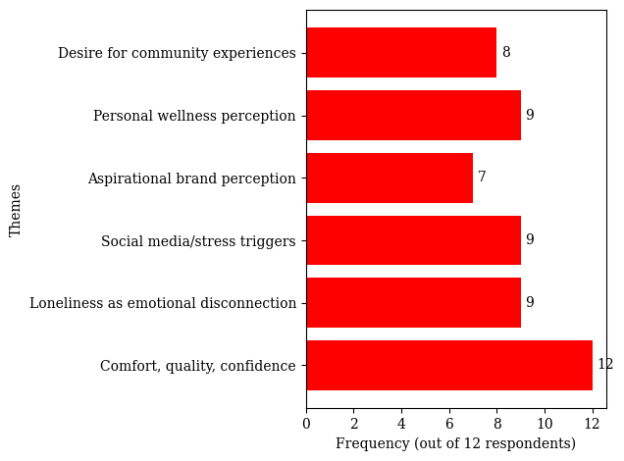
Fig 2: Theme frequency summary from qualitative interviews

3.4 Overall Implications for Research Questions and Questionnaire Design

The qualitative findings strongly supported and refined both research questions. For Research Question 1, the findings indicate that aspirational messaging can increase motivation and purchase intention, but may also create pressure or disconnection when perceived as unrealistic. For Research Question 2, the findings suggest that while Lululemon is currently viewed as a personal wellness brand, it has the potential to foster social connection through more inclusive and community-driven initiatives.

These insights were critical in translating abstract concepts such as loneliness, aspiration, and belonging into measurable survey variables, thereby strengthening the overall research design. These relationships are visually summarised in fig. 3, which presents a conceptual model linking loneliness, need for belonging, response to brand messaging, and purchase intention, with perceived social connection acting as a moderating variable.

The model illustrates how emotional disconnection drives a need for belonging, which shapes consumer responses to brand messaging and ultimately influences behavioural outcomes such as purchase intention and loyalty.

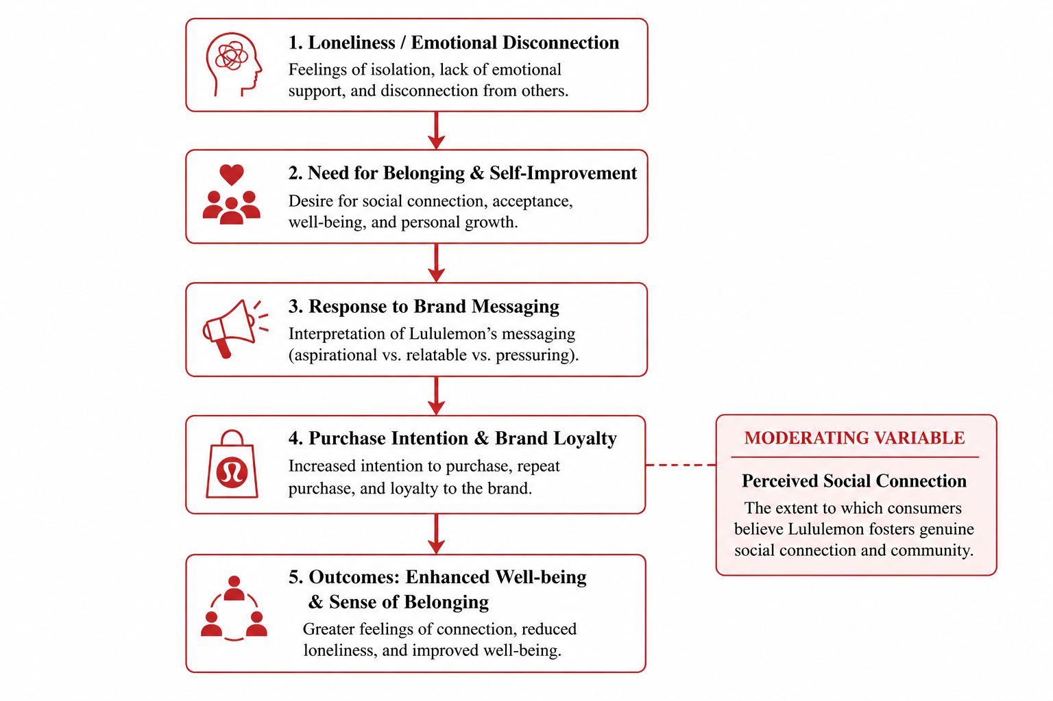

Fig 3: Conceptual model illustrating the relationship between loneliness, brand messaging, and consumer behaviour.

4. Questionnaire Design

4.1 Questionnaire Development and Structure

The questionnaire was developed using Qualtrics software and designed to systematically measure the variables related to the two core research questions. The survey consisted of 25 multiple-choice questions, primarily measured using five-point Likert scales to ensure consistency and reliability across responses. In addition, several classification and screening questions were included to support sample profiling and improve the accuracy of data analysis.

The questionnaire was organised into seven sections:
- Screening and Behavioral Questions - age, residency, purchase frequency, activewear usage
- Social Connection and Loneliness - measure respondents’ levels of emotional disconnection and feelings of loneliness
- Brand Recognition and Perception - examined respondents’ perceptions of Lululemon’s messaging, inclusivity. Product effectiveness and brand image
- Emotional Response to Brand Messaging - explored both positive (motivation, confidence) and negative (pressure, feelings of alienation) emotional responses
- Purchase Behavior and Consumption Tendencies - measure purchase intention and compensatory consumption behaviors
- Brand Community and Social Connection - examined whether consumers view Lululemon as fostering genuine social connection and community engagement or only as a source of personal comfort and self-enhancement
- Demographic Information - gender, employment status

4.2 Questionnaire Mapping to Research Questions

The questionnaire items were designed to directly address the study’s two research questions.

Research Question 1
How does Lululemon’s aspirational vs. neutral tone in messaging affect buying intentions and self-image amongst individuals experiencing isolation vs. belonging in society?

This research question was measured using:
- Q5–Q9: Loneliness Scale
- Q10–Q13: Brand Messaging Perception
- Q14–Q18: Emotional and Purchase Intention
These items measured respondents’ emotional states, perceptions of Lululemon’s brand messaging and behavioral intentions.

Research Question 2
Do consumers perceive Lululemon’s products and community programs as fostering genuine connection, or mere substitutes strengthening personal well-being?

This research question was measured using:
- Q21–Q23: Brand Community Value, Perceived Social Connection, Loyalty
These items evaluated whether respondents viewed Lululemon as contributing to authentic social belonging and creating community.

The remaining survey items supported demographic profiling and control variable analysis.

4.3 Qualtrics Survey Link

The questionnaire was distributed through Qualtrics using the following survey link:
https://q.surveys.unimelb.edu.au/jfe/form/SV_8GKRDQ73QOu9qKO?fbclid=PARlRTSASCJPZleHRuA2FlbQIxMABzcnRjBmFwcF9pZA8xMjQwMjQ1NzQyODc0MTQAAafl4_zY7pAE_FTtmz9a_JXSJawsq59cTtYzHDDf-LRCAGoS-pZ6YwRw5BZB4A_aem_DPib088CdEhMlPdKFRFuGg

4.4 Revisions from Week 6 Feedback

Based on feedback provided by the instructor, several revisions were made to improve the questionnaire’s reliability, clarity and consistency.

First, the age categories in the screening section were revised into evenly distributed intervals to better reflect the target sample population. The purchase frequency options were also reorganised into more logical intervals to reduce ambiguity and improve response accuracy.

Additionally, the wording and sentence structure of the loneliness scale were standardised to ensure consistency in presentation. Question 10, which previously combined the concepts of “ideal state” and “realistic state,” was separated into two distinct questions to minimise respondent confusion.

The wording of Question 11-13 was further refined to maintain consistency in tone and terminology when referring to idealised and realistic lifestyles. Similarly, Question 14-17 were revised to better differentiate emotional responses such as motivation, confidence, stress, and alienation while reducing conceptual overlap between items.

The Likert scale format used in Question 18 was aligned with the formatting of the other rating scales to maintain consistency throughout the survey. In Question 19, the scope was narrowed from general clothing purchases to specifically focus on activewear and sportswear purchases, thereby improving measurement precision.

Furthermore, the spelling and formatting inconsistencies were corrected, including the amendment of “Strongly diasgree” to “Strongly disagree.” Other formatting issues relating to spacing, capitalisation, and punctuation were also standardised to improve the professionalism and readability of the questionnaire.

5. Analysis & Result

5.1 Demographic Profile

The demographic profile of the respondents was analysed based on age, gender and employment status. A total of 126 respondents participated in this study. Descriptive statistics such as frequencies, percentages, modes and median categories were used to summarise the respondents’ characteristics.

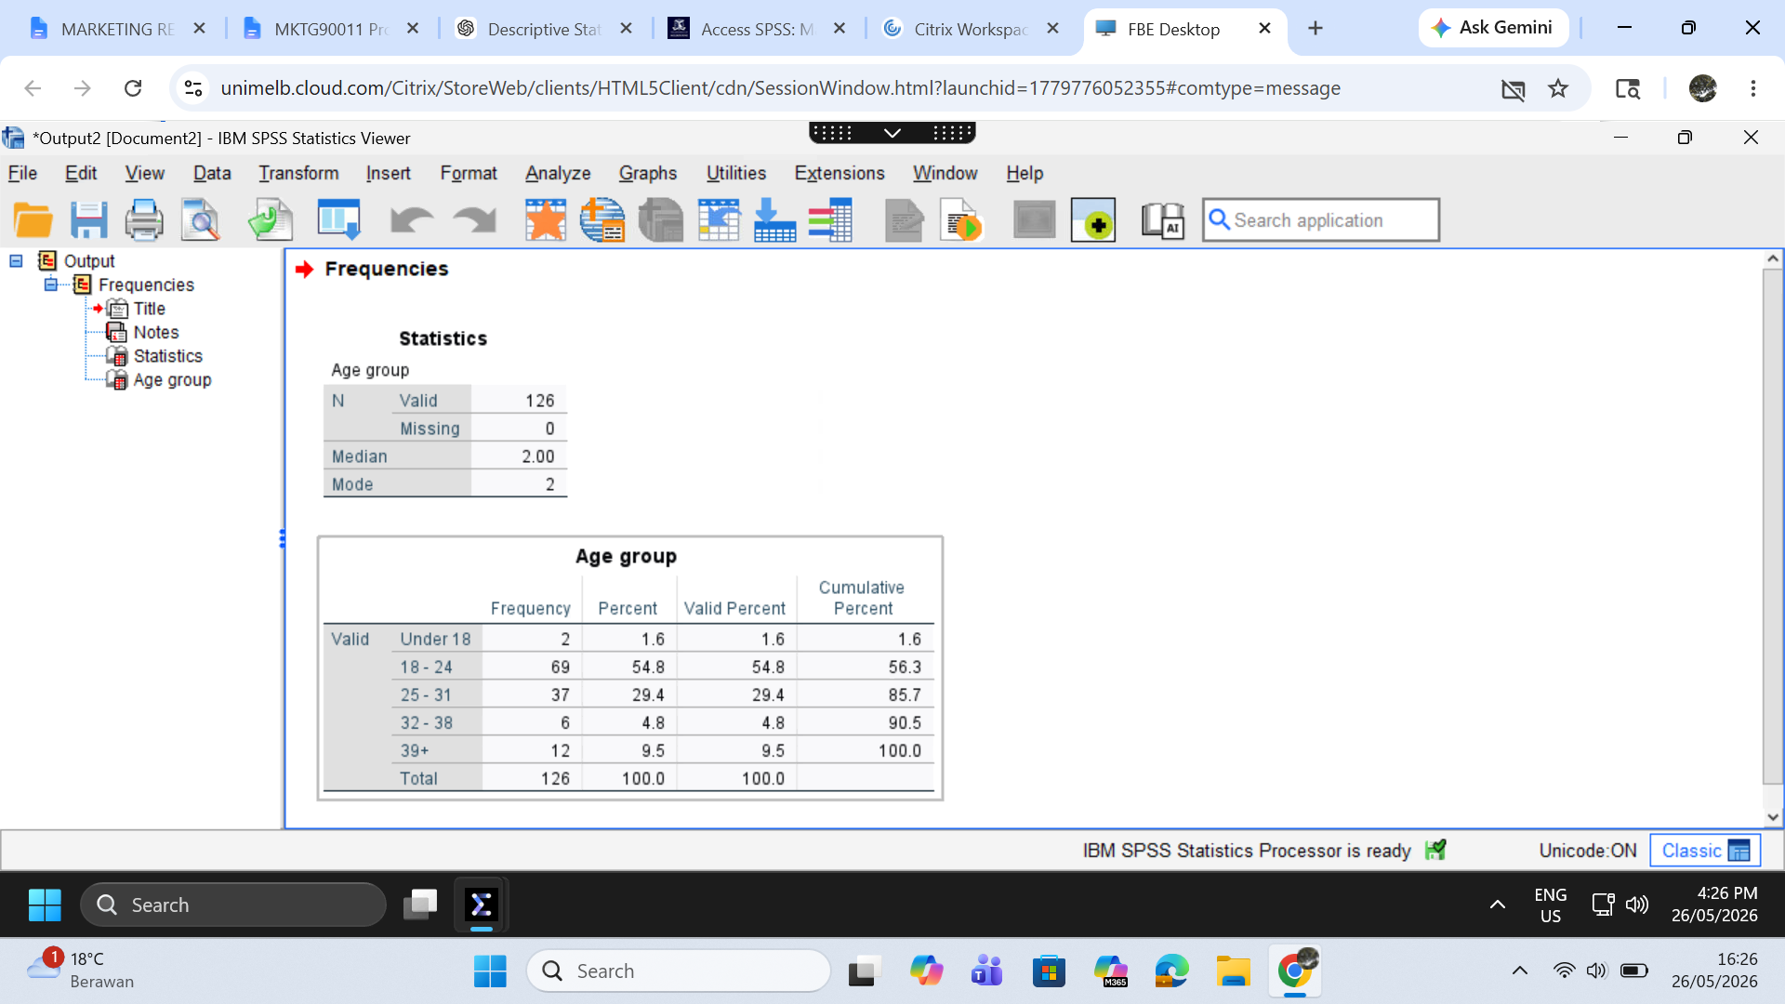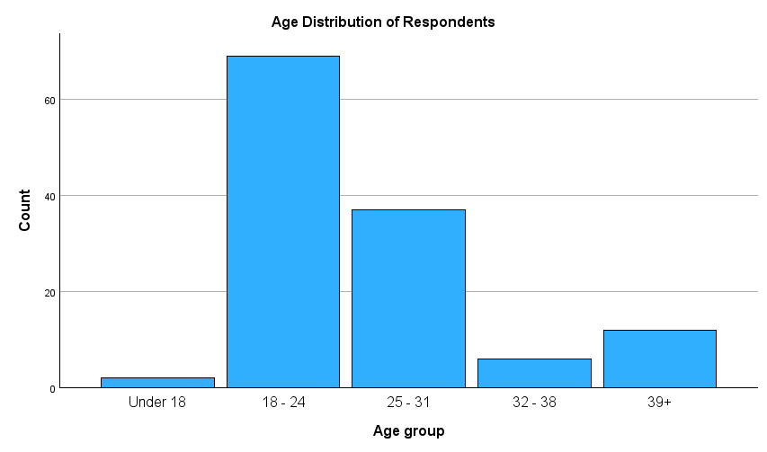

The majority of respondents were aged between 18 and 24 years old, representing 54.8% of the sample. Respondents aged 25-31 years accounted for 29.4%, while those aged 39 years and above represented 9.5% of the total respondents. In addition, respondents aged 32-38 years comprised 4.8% of the sample, whereas those below 18 years old accounted for 1.6%. The modal age category was 18-24 years, indicating that this was the most frequently represented age group. Based on the distribution, the median age category was also 18-24 years, indicating that the sample mainly consisted of young adults.

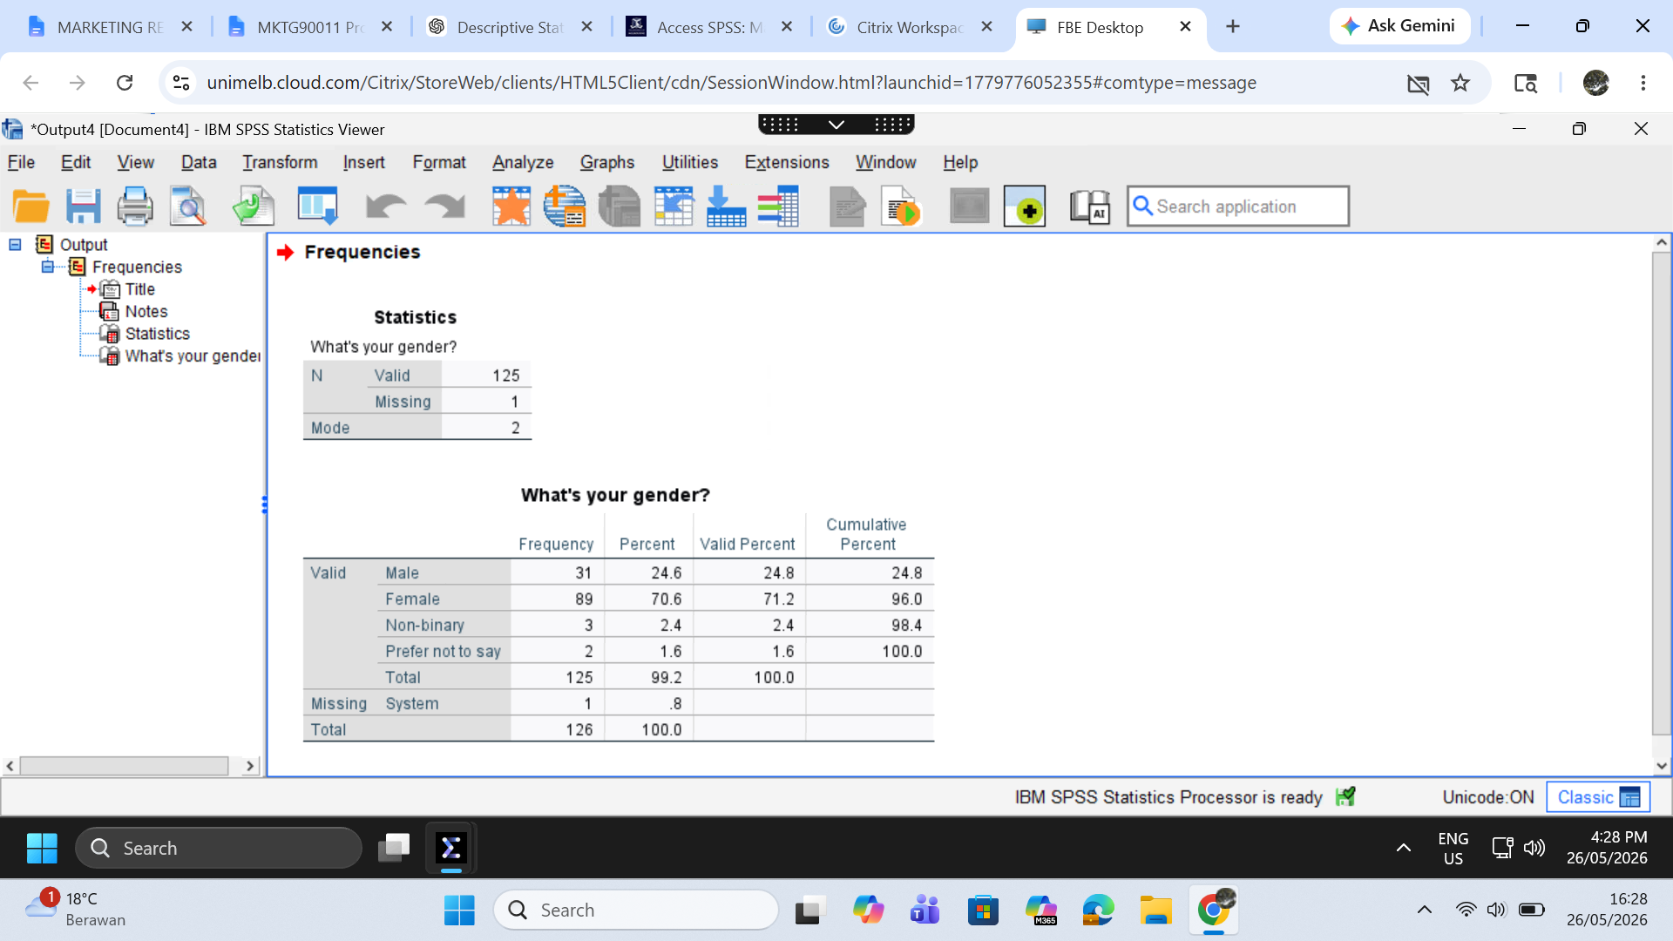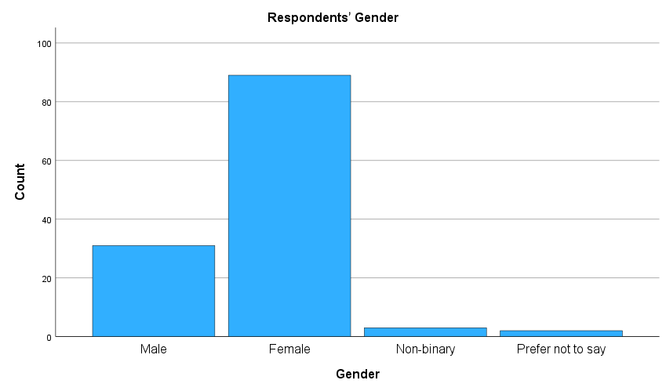
In terms of gender, 70.6% of respondents were female, 24.6% were male, 2.4% identified as non-binary and 1.6% preferred not to disclose their gender. The mode for gender was female, indicating that the sample was predominantly female.

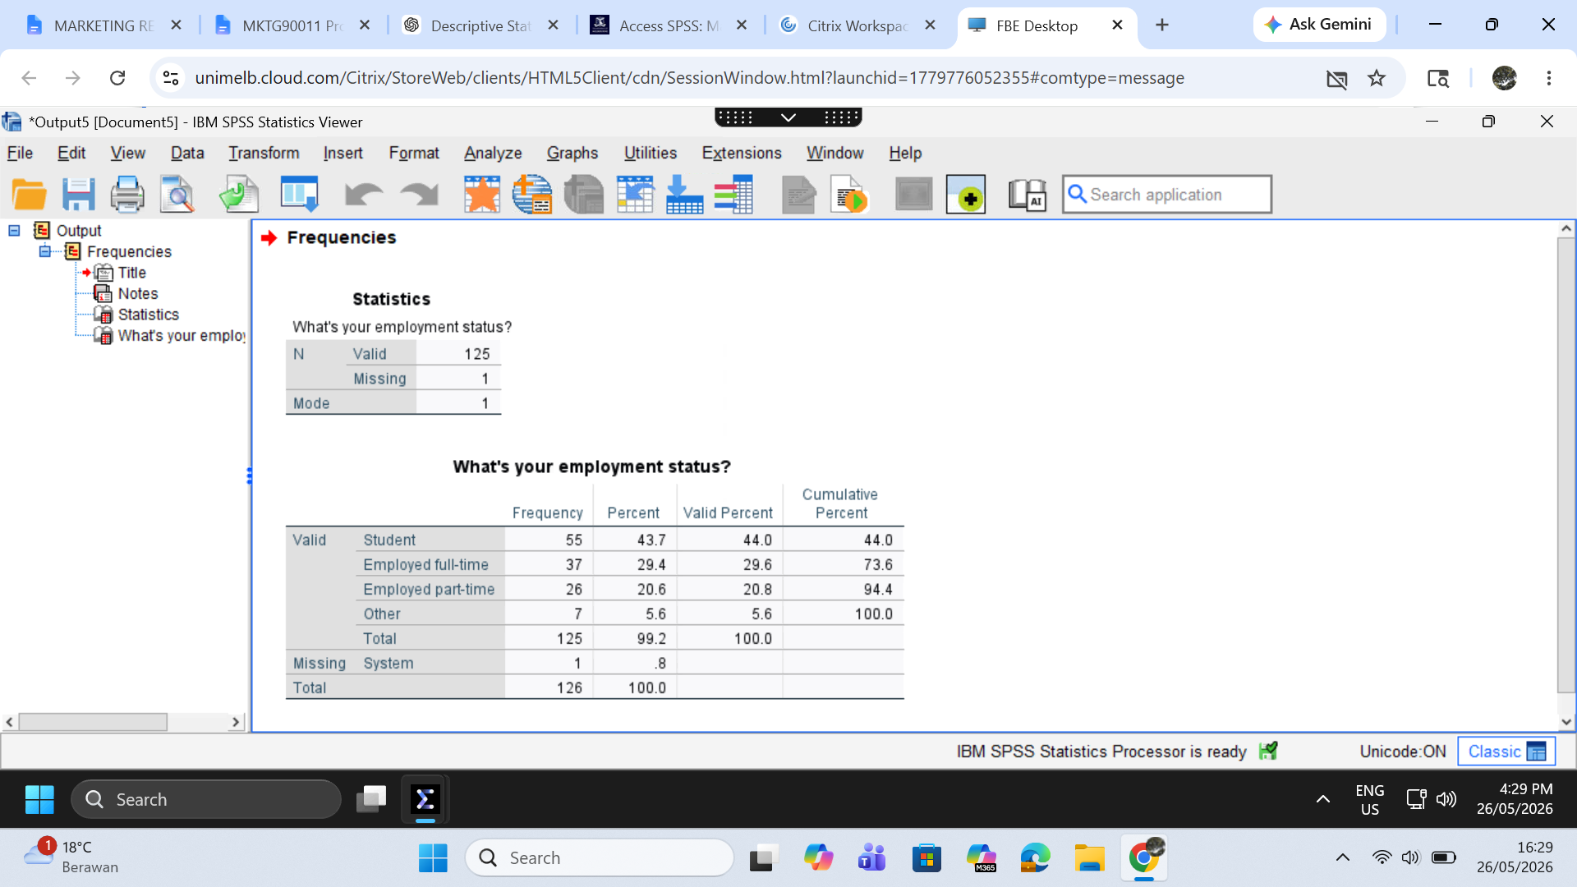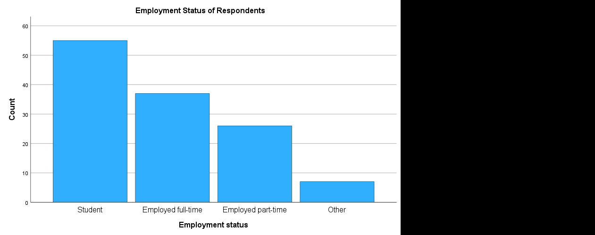

Regarding employment status, 43.7% of respondents were students, 29.4% were employed full-time, 20.6% were employed part-time and 5.6% were classified under other employment categories. The mode for employment status was student, suggesting that students formed the largest proportion of the sample.

Overall, the sample mainly consisted of female respondents aged 18-24 years who were students.

5.2 Results

5.2.1 Hypothesis 1: to be tested with Chi-square analysis

H0: There is no significant association between a consumer's loneliness level and their perception of Lululemon's community initiatives (genuine social connection vs. well-being substitute).
H1: There is a significant association between a consumer's loneliness level and their perception of Lululemon's community initiatives, specifically, consumers with high loneliness levels are more likely to perceive Lululemon's community as a well-being substitute rather than genuine social connection.
Table 1 below presents the case processing summary and crosstabulation, showing the observed and expected frequencies and row percentages for each combination of loneliness group (High/Low) and community perception (Genuine/Substitute).
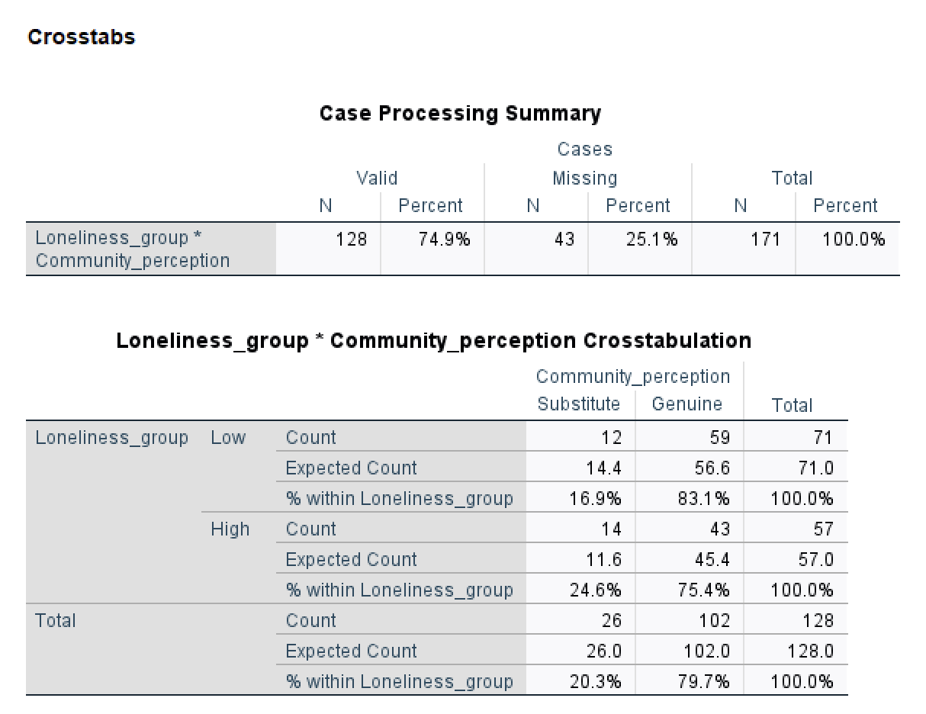
Table 2 below presents the chi-square test statistics and Cramér's V effect size, which together determine whether the observed association between loneliness level and community perception is statistically significant.
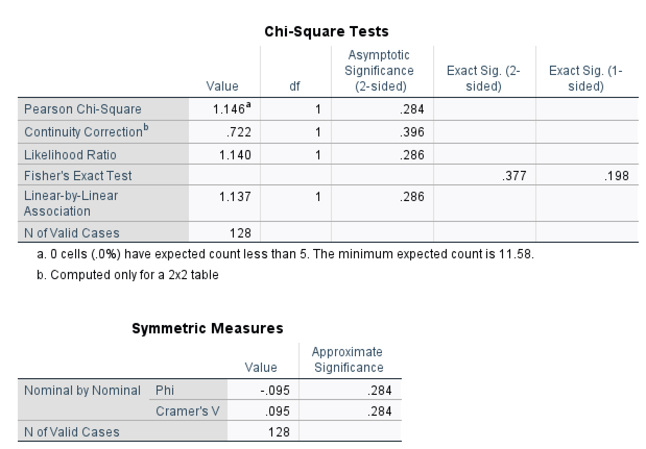

Results:
It was hypothesised that a consumer's level of loneliness would be significantly associated with how they perceive Lululemon's community initiatives — with high-loneliness consumers more likely to view them as personal well-being substitutes rather than genuine social connection. A chi-square test of independence was conducted using loneliness level (High/Low, derived via a median split of the composite Q5–Q9 loneliness score, Mdn = 2.40) and community perception (recoded from Q21 into Genuine connection vs. Well-being substitute).
Interpretation:
The results show no significant association between the two variables (χ²(1) = 1.146, p = .284), with a negligible effect size (Cramér's V = .095). All expected cell frequencies exceeded the minimum threshold of 5 (minimum expected count = 11.58), confirming that chi-square assumptions were fully satisfied. Inspection of the crosstabulation shows that both Low loneliness (83.1% Genuine) and High loneliness (75.4% Genuine) respondents predominantly perceived Lululemon's community as genuine, with only a marginal difference between the two groups. Therefore, H0 is retained and H1 is not supported. These findings suggest that scepticism toward Lululemon's brand community is not a loneliness-specific response, perceptions of community authenticity are broadly consistent across all consumers regardless of their personal experience of loneliness.

5.2.2 Hypothesis 2: to be tested with a t-test

Hypothesis:
H0: The population mean buying intention toward Lululemon after seeing their marketing does not significantly differ from the neutral level
H1: The population mean buying intention toward Lululemon after seeing their marketing is significantly higher than the neutral level

Table 3 below presents the results of the one-sample t-test, including the sample size, mean, standard deviations, test values, t-statistics and significance levels for the variable analysed (buying intention).
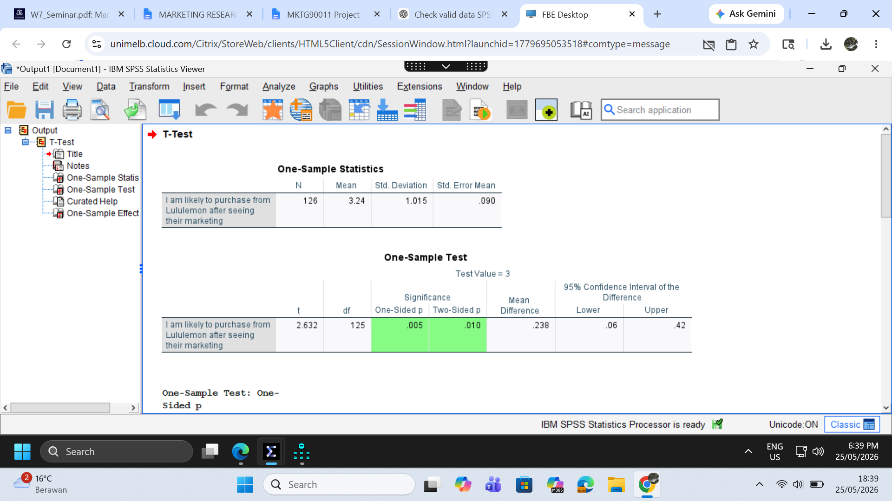

Results:
It was hypothesized that customers have an intention to buy Lululemon after exposure to its marketing. A one-sample t-test was conducted to compare the sample mean of buying intention against the test value of 3, the neutral point. The results show that the sample mean of buying intention (M = 3.24) is significantly higher than 3 (t(125) = 2.632; p < .01).

Interpretation:
The findings suggest that respondents demonstrated a higher-than-neutral intention to purchase Lululemon products after exposure to the brand’s marketing. This indicates that Lululemon’s marketing may positively influence customers' purchase intentions. Therefore, the hypothesis was supported.

5.2.3 Hypothesis 3: to be tested with a t-test (a different type of t-test from H2)

Hypothesis:
H0: There is no significant difference between individuals' perceptions of Lululemon’s impact on personal well-being and their perception of its impact on genuine social connection
H1: There is a significant difference between customers’ perceptions of Lululemon’s impact on personal well-being and their perception of its impact on genuine social connection

Table 4 below presents the paired-samples t-test results, showing the mean, standard deviations, mean differences and significance levels for the two related variables being compared (personal well-being and genuine social connection).
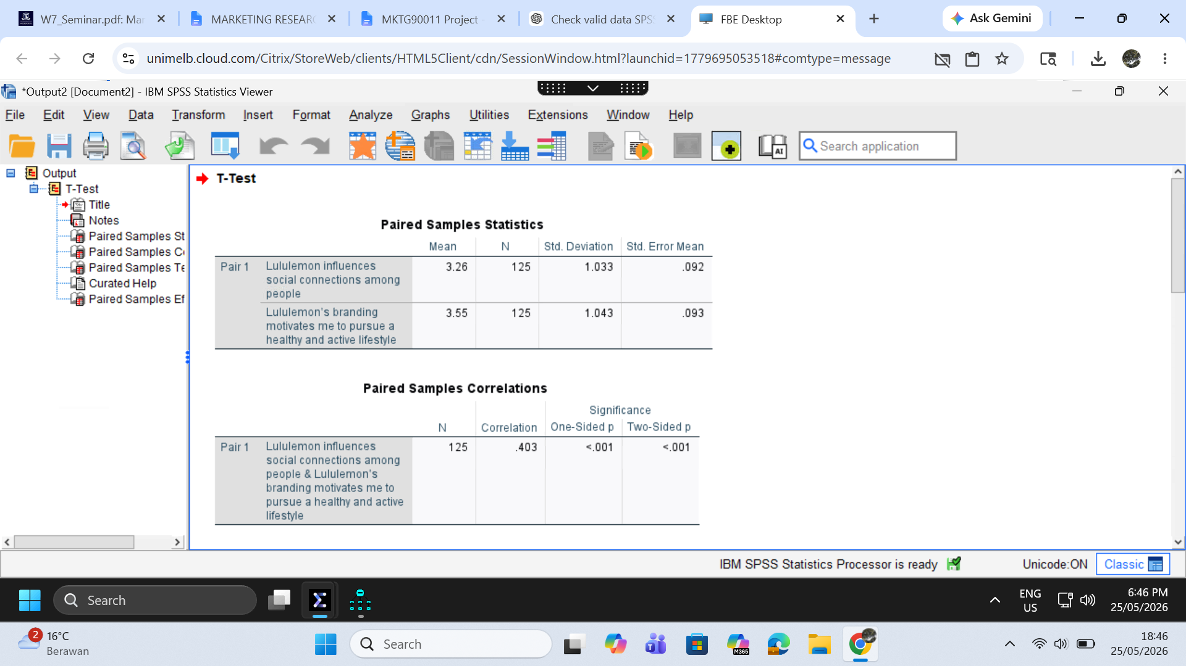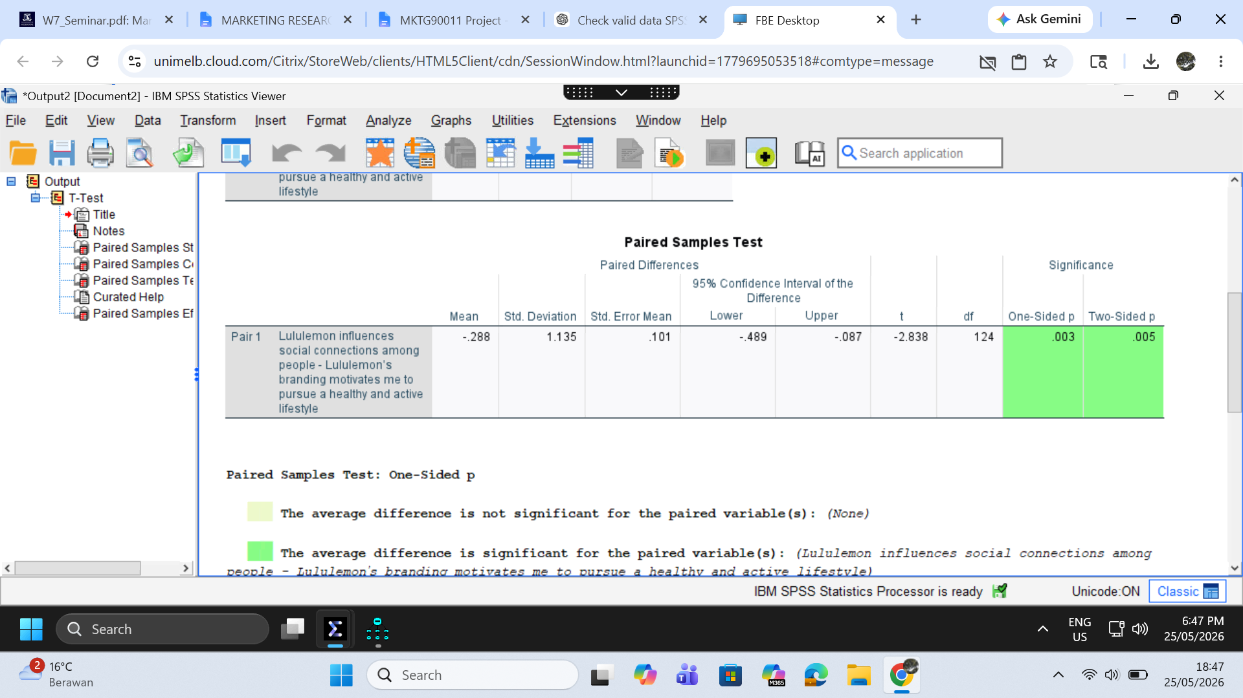

Results:

It was hypothesized that customers’ perception of Lululemon’s impact on personal well-being differs from their perception of its impact on genuine social connection. A paired samples t-test was conducted to examine this difference. The results show a significant difference between the two perceptions (t(124) = -2.838; p < .005). In particular, the perceived impact on personal well-being (M = 3.55) was higher than the perceived impact on genuine social connection (M = 3.26).

Interpretation:
The findings suggest that respondents perceived Lululemon as having a stronger impact on personal well-being than on fostering genuine social connection. This indicates that consumers are more likely to associate Lululemon with individual wellness and self-enhancement rather than meaningful interpersonal connection. Therefore, the hypothesis was supported.

5.2.4 Hypothesis 4: to be tested with one-way ANOVA

H0: There is no significant difference in purchase intention scores across consumers who perceive Lululemon's brand messaging as Aspirational, Neutral, or Relatable.
H1: At least one message tone group differs significantly in purchase intention scores from the others, specifically, consumers who perceive Lululemon's messaging as relatable will report significantly higher purchase intentions than those who perceive it as aspirational.
Table 3 below presents the descriptive statistics for each message tone group, Levene's test for homogeneity of variances, and the overall ANOVA result, showing whether mean purchase intention scores differ significantly across the three groups.
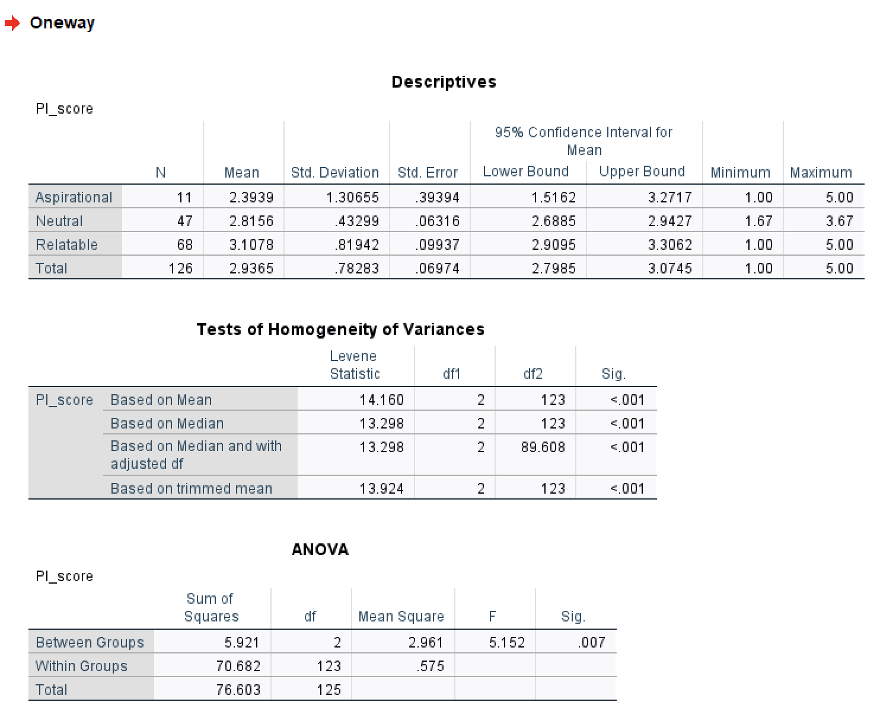
Table 4 below presents the ANOVA effect size (η²) and Tukey HSD post-hoc multiple comparisons, identifying which specific pairs of tone groups differ significantly from one another in their purchase intention scores.
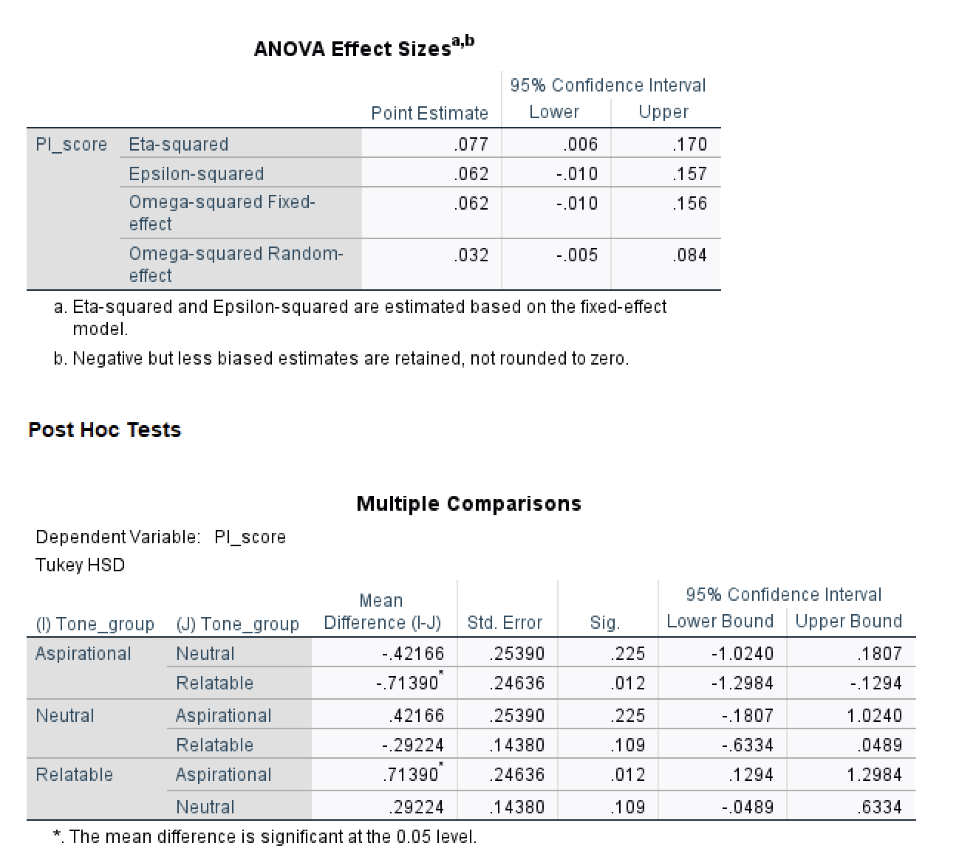
It was hypothesised that perceived message tone of Lululemon's branding would significantly affect consumers' purchase intentions, with relatable messaging producing higher purchase intent than aspirational messaging. A one-way ANOVA was conducted using message tone as the independent variable — recoded from Q10 into three groups: Aspirational (n = 11), Neutral (n = 47), and Relatable (n = 68) — and a composite purchase intention score (mean of Q18, Q19, Q20) as the dependent variable. The results show that message tone did significantly affect purchase intention scores (F(2, 123) = 5.152, p = .007, η² = .077), indicating that tone group accounted for approximately 7.7% of the variance in purchase intention. Levene's test indicated unequal variances across groups (F = 14.160, p < .001), which is noted as a limitation; however, given the significance of the F-statistic and adequate sample size, the result is considered sufficiently robust.
Results:
It was hypothesised that perceived message tone of Lululemon's branding would significantly affect consumers' purchase intentions, with relatable messaging producing higher purchase intent than aspirational messaging. A one-way ANOVA was conducted using message tone as the independent variable, recoded from Q10 into three groups: Aspirational (n = 11), Neutral (n = 47), and Relatable (n = 68) and a composite purchase intention score (mean of Q18, Q19, Q20) as the dependent variable. The results show that message tone did significantly affect purchase intention scores (F(2, 123) = 5.152, p = .007, η² = .077), indicating that tone group accounted for approximately 7.7% of the variance in purchase intention. Levene's test indicated unequal variances across groups (F = 14.160, p < .001), which is noted as a limitation; however, given the significance of the F-statistic and adequate sample size, the result is considered sufficiently robust.
Interpretation:
Further post-hoc Tukey HSD analyses show that consumers who perceived Lululemon's messaging as Relatable reported significantly higher purchase intentions than those who perceived it as Aspirational (M_{Relatable} = 3.11 vs. M_{Aspirational} = 2.39, p = .012). The comparisons between Aspirational and Neutral (p = .225) and Neutral and Relatable (p = .109) were not statistically significant. Therefore, H0 is rejected and H1 is supported. These findings suggest that Lululemon's current aspirational positioning may be suppressing purchase intent, and that a shift toward more relatable and authentic messaging could meaningfully improve consumer conversion and better address the brand's core challenge of fostering genuine inclusion.

5.2.5 Hypothesis 5: to be tested with multiple regression

Hypothesis

H0: Loneliness, emotional response, and perceived social connection do not significantly influence consumers’ purchase intention toward Lululemon.

H1: Loneliness, emotional response, and perceived social connection significantly influence consumers’ purchase intention toward Lululemon.

Before conducting regression analysis, we first tested the reliability of these three multiple scales . The loneliness scale is quite reliable (Cronbach's alpha = 0.80), as are the emotional response scale (alpha= 0.59) and the social connection scales (alpha is 0.65). These results are acceptable for exploratory research. Then we calculated a composite score for each indicator.

Results
A multiple regression analysis was conducted to examine whether loneliness, emotional response, and perceived social connection predict consumers’ purchase intention toward Lululemon.
Purchase intention was measured using Q18 (“I am likely to purchase from Lululemon after seeing their marketing”). Loneliness_Score, Emotional_Response_Score, and Social_Connection_Score were entered as predictor variables.
The overall regression model was statistically significant, F(3,124) = 5.836, p < .001, explaining 12.4% of the variance in purchase intention (R² = .124; Adjusted R² = .103).
Among the three predictors, only Emotional_Response_Score significantly predicted purchase intention (β = .222, p = .029). In contrast, Loneliness_Score (β = .003, p = .969) and Social_Connection_Score (β = .180, p = .074) were not statistically significant predictors.
Interpretation

The findings suggest that how consumers perceive the Lululemon brand directly affects their likelihood of purchasing products from this brand . If consumers have a particularly positive opinion of the brand, they are more likely to buy products from Lululemon after seeing advertisements for this company .

Regarding loneliness, it actually doesn't have much of an impact on whether people want to buy things. Similarly, those who feel connected to society are indeed more willing to spend money, but this connection isn't particularly strong. Therefore, this assumption holds partially true, as only emotional responses truly influence people's purchasing decisions.

5.2.6 Hypothesis 6: to be tested with any analysis technique

Hypothesis
H0: There is no significant relationship between perceived social connection and consumers’ purchase intention toward Lululemon.
H1: There is a significant positive relationship between perceived social connection and consumers’ purchase intention toward Lululemon.

Results
A Pearson correlation analysis was conducted to examine the relationship between perceived social connection and consumers’ purchase intention toward Lululemon.
The results revealed a significant positive correlation between Social_Connection_Score and purchase intention (r = .298, p < .001). Respondents who reported higher levels of perceived social connection were more likely to indicate stronger purchase intentions toward Lululemon

Interpretation
The findings indicate a moderate positive relationship between perceived social connection and purchase intention. Consumers who believe that Lululemon fosters social connection and community are more likely to purchase from the brand after exposure to its marketing.
These results suggest that social connection may play an important role in shaping consumer behaviour and brand engagement. Therefore, H0 is rejected and H1 is supported.

5.3 Summary Table
Hypothesis | Hypothesis Statement | RQ | Justification
H1
H2 | The average buying intention toward Lululemon after seeing their marketing is greater than 3 | RQ 1 | The interviews showed that Lululemon’s aspirational marketing, wellness positioning and confidence-enhancing image influence customers’ purchase intention
H3 | There is a significant difference between customers’ perceptions of Lululemon’s impact on personal well-being and their perception of its impact on genuine social connection | RQ 2 | The interviews showed that customers associated Lululemon more with personal wellness and confidence than with fostering social connection, indicating differing perceptions between the two impacts
H4
H5
H6

Hypothesis | Measurement Scale | Statistical Test
H1
H2 | V: I am likely to purchase from Lululemon after seeing their marketing (Interval, Likert Scale) | One Sample T-Test
H3 | V1: Lululemon influences social connections among people (Interval, Likert Scale)  V2: Lululemon’s branding motivates me to pursue a healthy and active lifestyle (Interval, Likert Scale) | Paired Samples T-Test
H4
H5
H6

We processed the data using SPSS software . First, we conducted some descriptive statistics to understand who the respondents were and to identify key variables . Then we used various methods to test various hypotheses, such as chi-square analysis, one sample t-test, paired samples t-test , one-way ANOVA, correlation analysis and multiple regression analysis. The purpose of this was to clarify the relationships between feelings of loneliness, brand recognition, emotional responses, community engagement and purchasing intentions.

H5: The Influence of Loneliness, Emotional Response, and Social Connection on Purchase Intention

Hypothesis Development

After reviewing numerous literature and studies, I have found that loneliness is becoming increasingly common and has become a significant issue . It affects how people think and act. Previous research has already indicated that lonely individuals may turn to brands or brand communities to seek emotional satisfaction and a sense of belonging . Additionally, having a positive impression of , and being able to make friends within it, can help consumers get closer to the brand, making them more willing to spend money when purchasing products .

Therefore, the following hypothesis was proposed:

Whether or not to buy Lululemon is related to feelings of loneliness, emotional responses and the social connections you experience . All these factors can make you more inclined to purchase their products .

5.3 Reliability Analysis
Before conducting regression analysis, we first tested the reliability of these multiple indicators to see if they are consistent within themselves.

The reliability of the Loneliness Scale (from Q5 to Q9, with Q8 and Q9) being scored reversed is quite high. Its Cronbach Alpha value is approximately 0.80, indicating strong internal consistency within the scale .

The Cronbach Alpha value for the emotional reaction scale (Q14 to Q17, with Q16 and Q 17 being scored in reverse) is 0.59. This value indicates that the reliability of the scale is fairly acceptable at a moderate level. Considering that our study is exploratory in nature, we have decided to keep this scale and continue with the subsequent analysis .

The Cronbach Alpha values for the Social Connections Scale (Q21–Q23) are 0.65. This value indicates that the scale is relatively reliable and acceptable. Therefore, it can be used in exploratory market research.

Based on these results, three composite variables were created: Loneliness_Score, Emotional_Response_Score, and Social_Connection_Score.

Multiple Regression Analysis
We conducted a multiple regression analysis to see if feelings of loneliness, emotional responses and social connections affect people's decisions to purchase Lululemon products .
Purchase intention (Q18: “I am likely to purchase from Lululemon after seeing their marketing”) was used as the dependent variable. The independent variables included Loneliness_Score, Emotional_Response_Score, and Social_Connection_Score.
The overall regression model was statistically significant, F(3,124) = 5.836, p < .001, indicating that the predictors collectively explained a significant proportion of variance in purchase intention. The model explained 12.4% of the variance in purchase intention (R² = .124; Adjusted R² = .103).
The following table summarizes the regression coefficients.
Predictor | Standardised Beta (β) | Sig.
Loneliness_Score | .003 | .969
Emotional_Response_Score | .222 | .029
Social_Connection_Score | .180 | .074
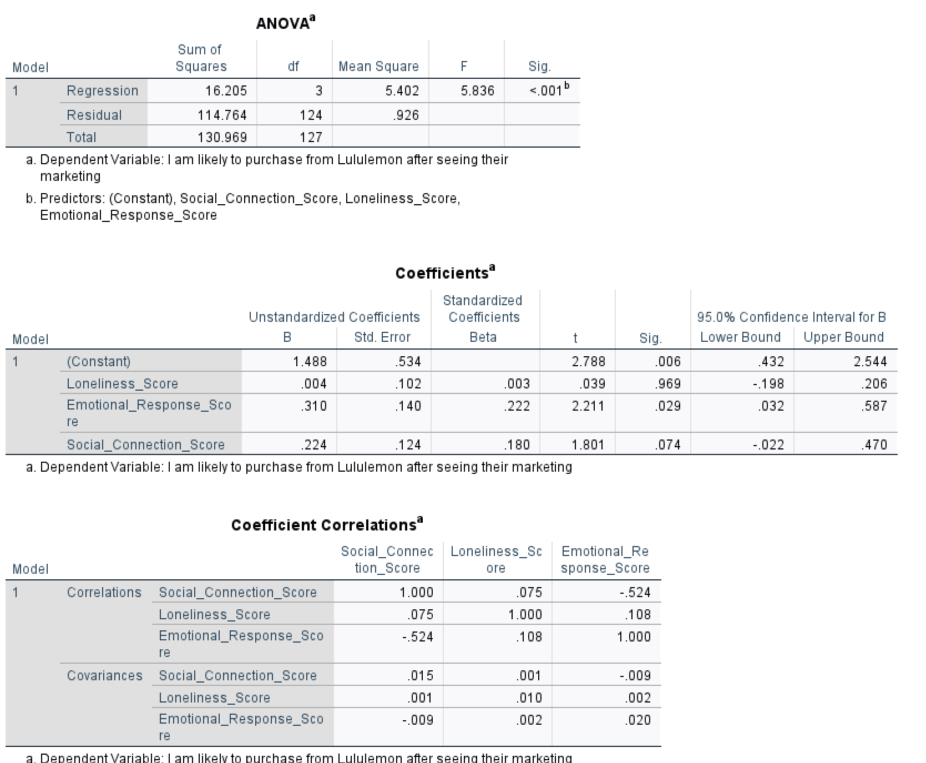
The results indicate that Emotional Response was the only significant predictor of purchase intention (β = .222, p = .029). People who experienced stronger positive emotional reactions toward Lululemon’s branding are more willing to spend money on their products after seeing their advertisements .
In contrast, Loneliness did not significantly predict purchase intention (β = .003, p = .969), suggesting that feelings of social isolation alone do not directly influence consumers’ likelihood of purchasing from Lululemon.
Similarly, Social Connection showed a positive but non-significant relationship with purchase intention (β = .180, p = .074). Although the result did not meet the conventional significance threshold of p < .05, it suggests a potential relationship that may warrant further investigation with a larger sample size.

H6: Pearson Correlation Analysis

Hypothesis: Perceived social connection is positively correlated with consumers' purchase intention toward Lululemon.
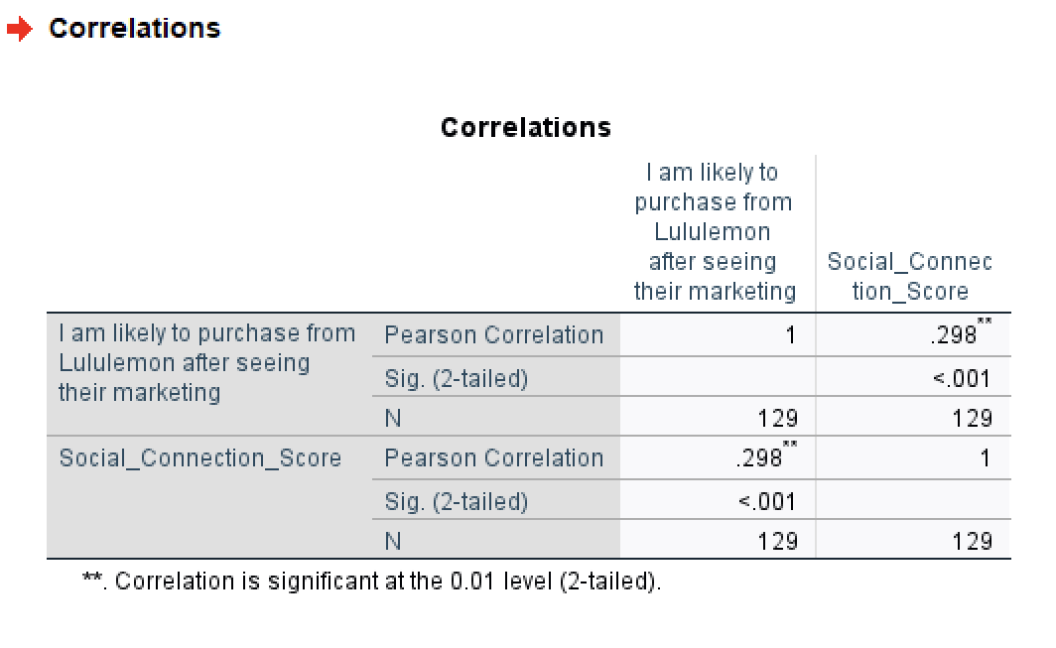

H6 Analysis & Results
A Pearson correlation analysis was conducted to examine the relationship between perceived social connection and consumers’ purchase intention toward Lululemon.
The results revealed a significant positive correlation between Social_Connection_Score and purchase intention (r = .298, p < .001). This shows that customers who believe that wearing Lululemon will help them meet more people and expand their social circle are more likely to buy their products after seeing their advertising campaigns .
This strength of this relationship is moderate which indicates that social circles have a meaningful impact on purchasing decisions. Research shows that groups of brand fans, activities they participate in together and places where they can chat with others contribute to a person's loyalty to one particular brand. Therefore, H6 is supported.

6. Conclusion and Recommendations

7. Reflection and Member Contributions

References

Appendices

- Interview guide
- A complete questionnaire in a Word document, and label the purpose of each question in the questionnaire (e.g., Q1 – Research question 1)

